PROJECT SYNOPSIS
━━━━━━━━━━━━━━━━━━━━━━━━━━━━━━━━━━━━━━━━
VidyTube
A Full-Stack YouTube-Style Video Streaming Platform
━━━━━━━━━━━━━━━━━━━━━━━━━━━━━━━━━━━━━━━━

Built with React · Node.js · Express · MongoDB

Submitted by
[Your Name]
[Roll Number / Registration Number]
Under the Guidance of
[Guide Name]
[Department / College Name]
[Academic Year 2025-26]

Table of Contents
1. Introduction
2. Problem Statement
3. Objectives
4. Technology Stack
5. System Architecture
6. Module Breakdown
6.1 Frontend Modules
6.2 Backend Modules
7. Key Algorithms
7.1 Trending Score
7.2 Content-Based Recommendations
8. Database Schema
9. Security Features
10. API Reference
11. Deployment Strategy
12. Testing
13. Future Scope
14. Conclusion
15. References

1. Introduction
VidyTube is a full-stack, YouTube-style video streaming web application developed as an academic project to demonstrate end-to-end expertise in modern web development. The platform replicates the core user experience of YouTube — including user registration, video uploading, streaming, social interactions (likes, comments, subscriptions), playlists, watch history, trending feeds, content-based recommendations, and a dedicated admin dashboard for content moderation and platform management.
The application follows a client-server architecture with a React-based Single Page Application (SPA) on the frontend communicating with a Node.js/Express RESTful API backend. All persistent data is stored in MongoDB, a NoSQL document database. The system supports Google OAuth sign-in alongside traditional email/password authentication, and is configured for deployment on Vercel's serverless infrastructure.
The project encompasses 19 distinct UI pages, 9 reusable components, 11 client-side service modules, 9 server-side controllers, 10 database models, and over 30 RESTful API endpoints — making it a comprehensive demonstration of full-stack engineering skills.
──────────────────────────────────────────────────────────────────────

2. Problem Statement
Modern video-sharing platforms such as YouTube are complex, multi-faceted systems that integrate diverse technical domains — from secure user authentication and large-file upload handling to recommendation algorithms and content moderation pipelines. Understanding how these systems function requires hands-on implementation rather than theoretical study alone.
VidyTube addresses this gap by constructing a feature-complete video platform from scratch, providing practical exposure to:
- Secure user authentication and role-based authorization (JWT + bcrypt)
- File upload handling for video and thumbnail media (Multer middleware)
- Real-time social interactions — likes, comments, subscriptions
- Algorithmic features — trending score computation and content-based recommendation
- Administrative oversight — platform analytics, user management, content moderation, and report resolution workflows
- Responsive, mobile-friendly UI design following YouTube's design patterns
──────────────────────────────────────────────────────────────────────

3. Objectives
1. Responsive UI: Develop a responsive, YouTube-like user interface using React 18 with modern component patterns, React Router for navigation, and a dark/light theme toggle.
2. Secure Authentication: Implement JWT-based stateless authentication with bcrypt password hashing, Google OAuth integration, and role-based access control (user vs. admin).
3. RESTful API: Build a comprehensive RESTful API (30+ endpoints) supporting CRUD operations for videos, comments, playlists, subscriptions, reports, community posts, and notifications.
4. Trending Algorithm: Design and implement a trending algorithm that combines view count, like count, and upload recency into a weighted score.
5. Recommendation Engine: Implement a content-based recommendation engine that analyzes the user's watch history to suggest relevant unwatched videos.
6. Admin Dashboard: Provide an admin dashboard with platform-wide statistics, user management (with cascading deletes), video moderation, and report review/resolution.
──────────────────────────────────────────────────────────────────────

4. Technology Stack
The project leverages a modern JavaScript/Node.js ecosystem, ensuring a unified language across client and server. Below is a detailed breakdown:
Layer | Technology | Purpose
Frontend Framework | React 18 + Vite | Component-based SPA with fast Hot Module Replacement (HMR)
Client Routing | React Router v6 | Declarative client-side navigation & protected route guards
HTTP Client | Axios | Promise-based HTTP communication with interceptors for auth tokens
Backend Runtime | Node.js | Server-side JavaScript runtime
Backend Framework | Express.js v4 | Minimal, flexible web application framework for REST APIs
Database | MongoDB | NoSQL document database for flexible schema design
ODM | Mongoose v8 | Object Document Mapper for schema validation & query building
Authentication | JSON Web Tokens (JWT) | Stateless token-based authentication with configurable expiry
Password Security | bcryptjs | Adaptive hashing with salt rounds for secure password storage
Google OAuth | google-auth-library + Firebase Admin | Google Sign-In verification and user identity management
File Uploads | Multer | Multipart form-data middleware for video & thumbnail uploads
Input Validation | express-validator v7 | Server-side request sanitization and validation chains
Deployment | Vercel | Serverless deployment with URL rewrites and static asset serving
Dev Tooling | Nodemon + Vite Dev Server | Auto-restart server & instant frontend hot-reload during development

──────────────────────────────────────────────────────────────────────

5. System Architecture
VidyTube follows a three-tier client-server architecture, cleanly separating the presentation layer (React SPA), the business logic layer (Express API), and the data layer (MongoDB). The diagram below illustrates the high-level data flow:
Architecture Diagram
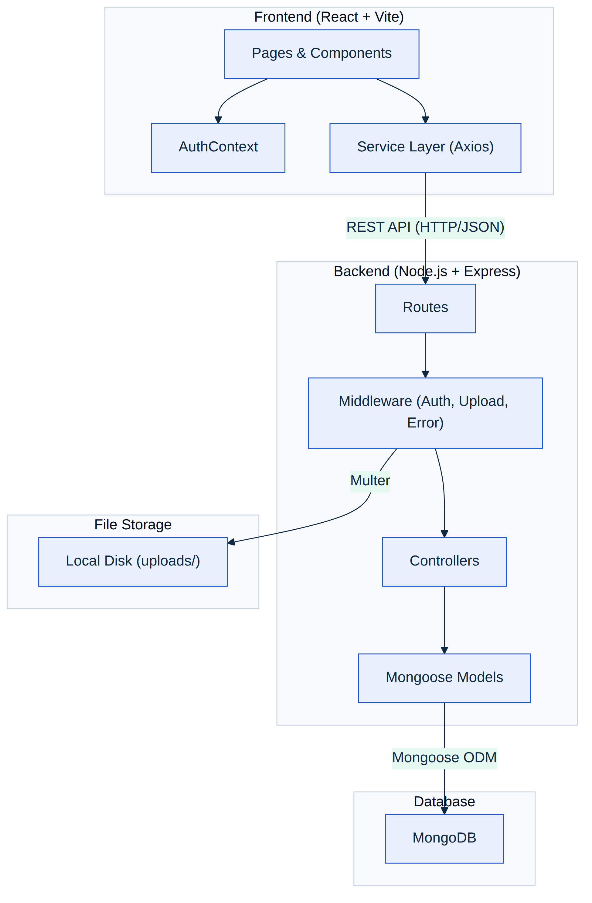

Data Flow:
- 1. User interacts with the React frontend (pages/components).
- 2. Service modules send HTTP requests (with JWT in Authorization header) to the Express backend.
- 3. Express routes pass requests through middleware (authentication, file upload, validation).
- 4. Controllers execute business logic and interact with Mongoose models.
- 5. Mongoose models perform CRUD operations against MongoDB.
- 6. Uploaded media files are stored on the local filesystem under uploads/.
- 7. Responses flow back to the client as JSON, updating the React UI.
──────────────────────────────────────────────────────────────────────

6. Module Breakdown

6.1 Frontend Modules
The frontend is organized into 19 page-level components, 9 reusable components, and 11 service modules that abstract API communication.

Pages (19)
Page | File | Functionality
Register | Register.jsx | New user registration form with validation
Login | Login.jsx | Email/password + Google OAuth sign-in
Home | Home.jsx | Video grid feed with category chips, search, skeleton loading
Watch | Watch.jsx | HTML5 video player, view counter, like/unlike, comments, share, report, save-to-playlist, related videos
Upload Video | UploadVideo.jsx | Video + thumbnail upload with type/size validation and progress bar
Shorts | Shorts.jsx | Short-form vertical video feed
Profile / Channel | Profile.jsx | User avatar, subscriber count, channel videos, community posts
Search Results | SearchResults.jsx | Full-text search results with filtering
Trending | Trending.jsx | Algorithmically ranked trending videos
Subscriptions | Subscriptions.jsx | Feed of videos from subscribed channels
History | History.jsx | Watch history timeline with clear-all action
Playlists | Playlists.jsx | Playlist management (create, view, delete)
Playlist Details | PlaylistDetails.jsx | Individual playlist with video list and remove capability
Favorites | Favorites.jsx | User's favorited videos
Liked Videos | LikedVideos.jsx | All videos the user has liked
Watch Later | WatchLater.jsx | Saved-for-later video list
Creator Studio | CreatorStudio.jsx | Channel analytics and video management for creators
Settings | Settings.jsx | Dark/light theme toggle, user preferences
Admin Dashboard | AdminDashboard.jsx | Platform stats, user/video management, report moderation

Reusable Components (9)
Component | Purpose
AppShell.jsx | Root layout wrapper with Navbar + Sidebar + content area
Navbar.jsx | Top navigation bar with search, upload button, notifications, user menu
Sidebar.jsx | Collapsible left sidebar with navigation links
MobileBottomNav.jsx | Bottom tab bar for mobile devices
VideoCard.jsx | Reusable video thumbnail card with title, channel, views, timestamp
SkeletonCard.jsx | Shimmer loading placeholder while videos are fetching
ProtectedRoute.jsx | Route guard that redirects unauthenticated users to login
AdminRoute.jsx | Route guard that restricts access to admin-role users only
GoogleSignInButton.jsx | Styled Google OAuth sign-in button with Firebase integration

Service Modules (11)
Service | Purpose
api.js | Axios instance with base URL and JWT interceptor
authService.js | Register, login, Google auth, get current user
videoService.js | Video CRUD, like, comment, trending, recommendations, shorts, download
userService.js | User profile, subscribe/unsubscribe
historyService.js | Record watch, get history, clear history
playlistService.js | Playlist CRUD, add/remove videos
adminService.js | Admin stats, user/video management, report handling
communityService.js | Community post CRUD
notificationService.js | User notifications fetch
libraryService.js | Favorites, liked videos, watch later management
youtubeService.js | External YouTube data fetching integration

6.2 Backend Modules
The backend is structured using the MVC (Model-View-Controller) pattern with 9 route groups, 9 controllers, 10 Mongoose models, and 3 middleware modules.
Module | Controller | Model(s) | Key Responsibilities
Auth | authController.js | User | Register, Login, Google OAuth, JWT generation, get current user
Videos | videoController.js | Video, Comment | CRUD, like/unlike, comments, report, trending, recommendations, shorts, download
Users | userController.js | User, Subscription | Profile retrieval, subscribe/unsubscribe, subscriptions list, avatar update
History | historyController.js | WatchHistory | Record watch event (de-duplicated), retrieve history, clear all history
Playlists | playlistController.js | Playlist | CRUD operations, add/remove videos from playlist
Admin | adminController.js | All models | Platform statistics, user management (cascading delete), video moderation, report resolution
Community | communityController.js | CommunityPost | Community posts creation, retrieval, interaction
Notifications | notificationController.js | Notification | User notification retrieval and management
YouTube | youtubeController.js | TrackedChannel | External YouTube API data fetching and channel tracking

Middleware
Middleware | Purpose
authMiddleware.js | Validates JWT tokens, attaches user object to request, enforces admin role checks
uploadMiddleware.js | Configures Multer for video + thumbnail file uploads with type/size validation
errorMiddleware.js | Centralized 404 handler and error response formatter with stack traces in development

──────────────────────────────────────────────────────────────────────

7. Key Algorithms

7.1 Trending Score Algorithm
The trending algorithm ranks videos using a weighted composite score that balances popularity (views and likes) with freshness (upload recency). This prevents old viral videos from permanently dominating the trending page.
Formula:
Score = (views × 0.6) + (likeCount × 0.3) + (recentness × 0.1)

Where:
- views: views — total view count of the video
- likeCount: likeCount — total number of unique likes
- recentness — a linear decay factor from 1.0 (uploaded today) to 0.0 (uploaded 14+ days ago)

Recentness Calculation:
recentness = max(0, 1 - (daysSinceUpload / 14))
Videos older than 14 days receive zero recentness bonus but can still rank via views and likes alone.

7.2 Content-Based Recommendation Algorithm
The recommendation engine uses a content-based filtering approach, analyzing the user's viewing patterns to suggest relevant unwatched content.
Algorithm Steps:
- Fetch the user's last 20 watched videos from WatchHistory.
- Extract the set of categories and a keyword bag from video titles in the history.
- For each candidate video (not yet watched by the user):
- a. Award points for matching the user's preferred categories.
- b. Award points for title keyword overlap with the user's watched video titles.
- c. Compute a composite relevance score.
- Sort candidates by descending relevance score and return the top results.
- Fallback: If the user has no watch history, return the most-popular videos ranked by view count.
──────────────────────────────────────────────────────────────────────

8. Database Schema
The database uses MongoDB with Mongoose as the ODM layer. There are 10 collections (models), connected through ObjectId references. Below is a summary of each model and its key fields:
Model | Key Fields | Relationships
User | name, email, password (hashed), avatar, role (user/admin), subscribersCount | Has many: Videos, Comments, Subscriptions, WatchHistory, Playlists, Reports, CommunityPosts, Notifications
Video | title, description, category, videoUrl, thumbnailUrl, views, likes[], likeCount, duration, isShort | Belongs to: User (uploader). Has many: Comments, Reports
Comment | text, likes, replies[] | Belongs to: User (author), Video
Subscription | subscriber, channel, createdAt | References: User (subscriber) → User (channel)
WatchHistory | watchedAt (auto-updated on re-watch for de-duplication) | References: User → Video
Playlist | name, description, videos[] | Belongs to: User. References: Video[]
Report | reason, description, status (pending/resolved), resolvedBy | References: User (reporter) → Video
CommunityPost | content, likes[], comments[] | Belongs to: User (author)
Notification | type, message, read, relatedVideo, relatedUser | Belongs to: User
TrackedChannel | channelId, channelTitle, lastChecked | Belongs to: User

Entity Relationships:
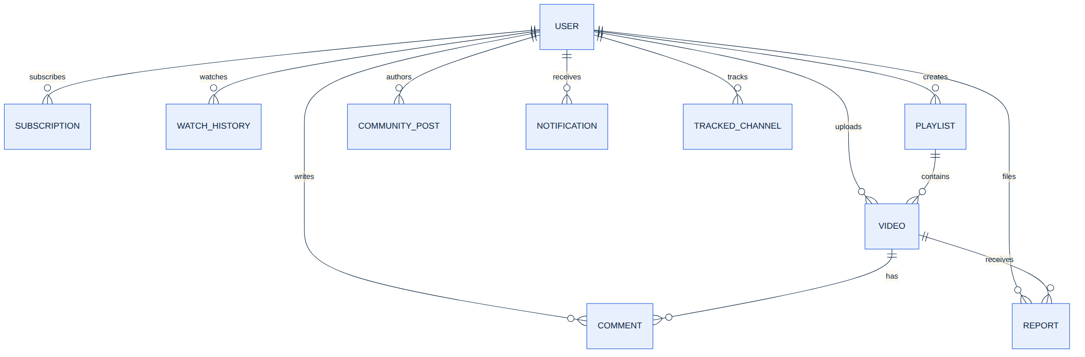
──────────────────────────────────────────────────────────────────────

9. Security Features
• JWT Authentication: Stateless token-based authentication. Tokens are generated on login, stored client-side, and sent via the Authorization header on every private request. Configurable expiry (default: 7 days).
• Password Hashing: All passwords are hashed using bcryptjs with multiple salt rounds before storage. Plain-text passwords are never persisted.
• Protected Routes (Client): ProtectedRoute and AdminRoute components wrap sensitive pages, redirecting unauthenticated or unauthorized users to the login page.
• Server-side Authorization: authMiddleware.js validates JWT on every private endpoint. Admin endpoints additionally verify role === 'admin'. Invalid or expired tokens return HTTP 401.
• Input Validation: express-validator middleware chains sanitize and validate all incoming request data (email format, password length, required fields, etc.) before reaching controllers.
• CORS Configuration: Cross-Origin Resource Sharing is explicitly configured to control which domains can access the API.
• File Upload Validation: Multer middleware enforces allowed MIME types (video/mp4, image/jpeg, etc.) and maximum file size limits, rejecting invalid uploads before they reach the controller.
• Google OAuth Verification: Google ID tokens are verified server-side using google-auth-library and Firebase Admin SDK, preventing token forgery.
──────────────────────────────────────────────────────────────────────

10. API Reference
The backend exposes 30+ RESTful endpoints organized into 9 route groups. Below is a comprehensive reference:

Authentication
Method | Endpoint | Access | Description
POST | /api/auth/register | Public | Create a new user account
POST | /api/auth/login | Public | Authenticate and receive JWT
POST | /api/auth/google | Public | Google OAuth sign-in
GET | /api/auth/me | Private | Get current authenticated user

Videos
Method | Endpoint | Access | Description
GET | /api/videos?category=&search= | Public | List/search videos with filtering
POST | /api/videos | Private | Upload video (multipart: video + thumbnail)
GET | /api/videos/:id | Public | Get single video, increments view count
DELETE | /api/videos/:id | Private | Delete video (owner or admin only)
POST | /api/videos/:id/like | Private | Toggle like (duplicate-proof)
GET | /api/videos/:id/comments | Public | List comments for a video
POST | /api/videos/:id/comments | Private | Add a comment
POST | /api/videos/:id/report | Private | Report a video for review
GET | /api/videos/trending/list | Public | Get algorithmically ranked trending videos
GET | /api/videos/recommendations/list | Private | Get personalized recommendations

Users & Subscriptions
Method | Endpoint | Access | Description
GET | /api/users/:id | Public | Get channel/profile information
POST | /api/users/:id/subscribe | Private | Toggle subscribe/unsubscribe
GET | /api/users/subscriptions/mine | Private | List my subscriptions

History, Playlists & Admin
Method | Endpoint | Access | Description
GET | /api/history | Private | Get watch history
POST | /api/history | Private | Record a watch event
DELETE | /api/history | Private | Clear all watch history
GET | /api/playlists | Private | List user's playlists
POST | /api/playlists | Private | Create a new playlist
GET | /api/playlists/:id | Private | Get a single playlist
PUT | /api/playlists/:id | Private | Update playlist (add/remove video, rename)
DELETE | /api/playlists/:id | Private | Delete a playlist
GET | /api/admin/stats | Admin | Platform-wide statistics
GET | /api/admin/users | Admin | List all users
DELETE | /api/admin/users/:id | Admin | Delete user + cascade their videos
GET | /api/admin/videos | Admin | List all videos
DELETE | /api/admin/videos/:id | Admin | Remove a video
GET | /api/admin/reports | Admin | List all reports
PUT | /api/admin/reports/:id | Admin | Mark report as resolved

──────────────────────────────────────────────────────────────────────

11. Deployment Strategy
VidyTube is configured for deployment on Vercel, leveraging its serverless functions and static hosting capabilities:
• Serverless API: The Express backend is wrapped in a Vercel serverless function (api/index.js). All /api/* requests are routed to this function via vercel.json rewrites.
• Static Frontend: The React app is built using Vite (npm run build) and the resulting dist/ directory is served as static assets.
• SPA Routing: A catch-all rewrite rule routes all non-API paths to index.html, enabling React Router's client-side routing.
• Environment Variables: Sensitive configuration (MongoDB URI, JWT secret, Firebase credentials) is managed through environment variables, with .env.example provided as a template.
──────────────────────────────────────────────────────────────────────

12. Testing
The project includes multiple test scripts for validating backend functionality:
Test Script | Purpose
test-search.js | Validates MongoDB full-text search on video title/description
test-trending.js | Verifies the trending score algorithm output
test-download.js | Tests video file download functionality
test-shorts.js | Validates short-form video filtering and retrieval
test-shorts-debug.js | Debug-level testing for shorts edge cases
test-specific-video.js | Tests fetching a specific video by ID
test-telugu-video.js | Tests regional language content handling
test-video-detail.js | Validates complete video detail response structure
test-upgrade.js | Tests schema migration and upgrade scenarios

The Express application boots cleanly with all routes mounted, and the React client builds successfully with npm run build. Both server and client have been syntax-verified file-by-file.
──────────────────────────────────────────────────────────────────────

13. Future Scope
1. Cloud Storage Integration: Replace local Multer file storage with Cloudinary or AWS S3. The architecture is designed for this — only uploadMiddleware.js and the URL fields on the Video model need modification.
2. ML-Based Recommendations: Upgrade from the current content-based algorithm to collaborative filtering or a neural recommendation model for improved personalization.
3. Live Streaming: Add WebRTC or HLS-based live streaming capabilities, enabling creators to broadcast in real-time.
4. Monetization System: Integrate ad-serving infrastructure and creator revenue-sharing mechanisms.
5. Mobile Application: Extend the platform to React Native or native Android/iOS applications for a native mobile experience.
6. Advanced Analytics: Implement detailed creator analytics dashboards with viewer demographics, engagement metrics, audience retention graphs, and revenue tracking.
7. Content Delivery Network (CDN): Integrate a CDN for global video delivery, reducing latency and improving playback quality for geographically distributed users.
8. Automated Content Moderation: Implement AI-based content moderation using computer vision and NLP to automatically detect and flag inappropriate content.
──────────────────────────────────────────────────────────────────────

14. Conclusion
VidyTube is a comprehensive, production-grade video streaming platform that demonstrates end-to-end full-stack web development proficiency. The project covers a wide spectrum of modern web engineering disciplines:
- Secure user authentication and authorization (JWT + bcrypt + Google OAuth)
- Media handling with validation and structured file storage
- Rich social interaction features (likes, comments, subscriptions)
- Algorithmic content discovery (trending scores and content-based recommendations)
- Administrative tooling for platform governance and content moderation
- Responsive, mobile-friendly UI design following YouTube's established UX patterns
- RESTful API design with 30+ well-structured endpoints
- Deployment-ready architecture with Vercel serverless configuration

The modular MVC architecture ensures maintainability and testability. The clean separation of concerns — between client services, server controllers, middleware, and data models — makes the codebase readily extensible for the future enhancements outlined above. VidyTube serves as both a functional video platform and a robust portfolio piece demonstrating industry-standard development practices.
──────────────────────────────────────────────────────────────────────

15. References
[1] React Documentation — https://react.dev/
[2] Node.js Documentation — https://nodejs.org/en/docs/
[3] Express.js Guide — https://expressjs.com/en/guide/routing.html
[4] MongoDB Manual — https://www.mongodb.com/docs/manual/
[5] Mongoose ODM Documentation — https://mongoosejs.com/docs/guide.html
[6] JSON Web Tokens (RFC 7519) — https://datatracker.ietf.org/doc/html/rfc7519
[7] Vite Build Tool — https://vitejs.dev/guide/
[8] React Router v6 — https://reactrouter.com/en/main
[9] Multer File Upload Middleware — https://github.com/expressjs/multer
[10] Firebase Admin SDK — https://firebase.google.com/docs/admin/setup
[11] Vercel Deployment — https://vercel.com/docs
[12] bcryptjs Password Hashing — https://github.com/dcodeIO/bcrypt.js

